|  |  |  |
| --- | --- | --- |
| f |  |  |
| **Benha University** |  | **Faculty of Computers & Artificial Intelligence** |

**Fruit classification**

**AI Departement**

***Project Team***

1. Student1 name
2. Student2 name
3. Student3 name
4. Student4 name
5. Student5 name

***Under Supervision of***

**Dr. Ibrahim Zagloul**

**En. Mahmoud Mansour**

May 2024

ABSTRACT

The document delves into the collaborative efforts of six college students hailing from the University of Benha, as they embarked on the development of a Convolutional Neural Network (CNN) model tailored for fruit classification. Employing Python as their primary programming language, they skillfully integrated various libraries including **TensorFlow, NumPy, Pandas, and Keras**. Their model's foundation lies in the comprehensive Fruits-360 dataset sourced from Kaggle, ensuring a diverse and robust training regimen. Through meticulous iterations and fine-tuning, they cultivated a sophisticated tool capable of discerning the subtle nuances among different fruit varieties.

Table of Contents

List of figures ii

list of tables iii

LIST OF ACRONYMS/ABBREVIATIONS iv

1 Introduction 1

2 formatting description 2

2.1 Title Page 2

2.2 General Project Layout 3

2.3 Page and Text Setting 4

2.3.1 Sub-Heading Level 1 5

2.4 Figures and Tables 6

2.4.1 Figure Captions and Table Titles 6

2.4.2 Numbering of Figures and Tables 7

2.4.3 Referring to Figures and Tables in Text 7

2.5 General Recommendations 8

2.5.1 Units 8

2.5.2 Abbreviations and Acronyms 8

2.5.3 Equations 8

2.5.4 Other Recommendations 9

3 citation and referencing 10

3.1 References Format 10

3.2 References to Electronic Sources 12

LIST OF ACRONYMS/ABBREVIATIONS

|  |  |
| --- | --- |
| ACRONYM | Definition of Acronym |
| CCN  EDA | Convolutional neural network  Exploratory data analysis |

# Introduction

In the field of artificial intelligence, the development of robust classification models stands as a fundamental pursuit with wide-ranging applications. Among these, the task of fruit classification holds practical significance, particularly in domains such as agriculture, food processing, and quality control. Motivated by the potential of Convolutional Neural Networks (CNNs) to excel in image classification tasks, a team of six dedicated students from the University of Benha undertook a systematic approach to construct a CNN model specialized for fruit classification.

Within the context of burgeoning interest in machine learning and neural networks, CNNs have emerged as a preferred choice for their ability to extract complex features from visual data. With a commitment to scientific rigor and methodical exploration, the team embarked on a comprehensive journey that encompassed data acquisition, preprocessing, model development, and evaluation.

Central to their methodology was the selection of the [**Fruits-360**](https://www.kaggle.com/datasets/moltean/fruits?rvi=1) dataset, a well-curated collection of labeled fruit images available on **Kaggle**. This dataset served as the foundation for training and validating their model, ensuring a diverse representation of fruit varieties and facilitating robust performance assessment.

Employing Python as their primary programming language, the team leveraged industry-standard libraries and frameworks, including **TensorFlow, NumPy, Pandas, and Keras**, to implement their CNN architecture. Through iterative experimentation and parameter tuning, they systematically refined the model's architecture to optimize classification accuracy and generalization.

Deciding on the Idea:

In our inaugural foray into neural network modeling, the path forward appeared both promising and daunting. With a shared determination to navigate the complexities of machine learning, we convened virtually via Google Meet to embark on a brainstorming session. Our objective was twofold: to identify a project idea that was both novel and feasible, and to pinpoint an existing dataset that would expedite our progress given our resource constraints. After much deliberation, we arrived at a unanimous decision: fruit classification—a task that promised both technical challenge and practical applicability.

The Technologies Used:

Having settled on our project domain, our next step was to delineate the technological framework that would underpin our endeavor. Python emerged as the natural choice, owing to its preeminence in the realm of machine learning and its robust ecosystem of libraries and tools. Among these, we identified several indispensable libraries that would facilitate various aspects of our project. Numpy would empower us with array manipulation capabilities, while Pandas would streamline our data preprocessing workflows. TensorFlow, with its comprehensive suite of machine learning tools, would serve as the cornerstone for building our neural network model. Additionally, we recognized the utility of auxiliary libraries such as glob for directory traversal, cv2 for image processing, and Matplotlib for data visualization—a cohesive ensemble of technologies poised to propel our project forward.

Task Distribution:

With our technological infrastructure in place, we turned our attention to task distribution—a critical aspect of project management that would capitalize on each team member's strengths and expertise. Dividing responsibilities based on individual proficiencies, we delineated a series of tasks essential to the project's success. These encompassed data gathering and file handling, essential data visualizations, meticulous data preprocessing, model development and testing—including the application of performance metrics such as confusion matrices and F1 scores—and, finally, the pivotal phase of model deployment. Each task, meticulously curated to leverage the unique talents of our team members, would be expounded upon in greater detail in the subsequent sections, underscoring our commitment to a collaborative and methodical approach

Data gathering

Since we couldn’t gather data from scratch we decided on downloading one from the interne. Kaggle to be precise it didn’t take to long to settle on the fruit-360 dataset.

A dataset with 90380 images of 131 fruits, vegetables and nuts. The dataset we selected for our fruit classification project is a treasure trove of visual data, comprising a staggering 90,380 images spanning a diverse spectrum of 131 fruits, vegetables, and nuts. This expansive collection offers a rich tapestry of botanical specimens, ranging from familiar fruits like apples, bananas, and oranges to more exotic offerings such as durians, dragon fruits, and lychees. In addition to fruits, the dataset encompasses a variety of vegetables and nuts, further enriching its diversity and scope.

Each image within the dataset serves as a digital snapshot, encapsulating the unique morphology, coloration, and texture of its respective fruit, vegetable, or nut. From the vibrant hues of ripened berries to the rugged exteriors of root vegetables, every image offers a nuanced portrayal of botanical diversity—an invaluable resource for our classification endeavor.

Furthermore, the dataset's comprehensive coverage of 131 distinct classes ensures ample representation across various taxonomic categories, geographical regions, and culinary traditions. Whether it's the iconic symbols of tropical abundance or the humble staples of everyday cuisine, this dataset encapsulates the breadth and depth of botanical diversity with remarkable fidelity.

Moreover, the sheer volume of images—exceeding 90,000 in total—provides an unprecedented wealth of training data, enabling our neural network model to glean intricate patterns and features essential for accurate classification. By leveraging this extensive dataset, we aim to cultivate a robust and versatile model capable of discerning subtle distinctions between a myriad of botanical specimens with precision and reliability.

In essence, the dataset serves as the bedrock upon which our classification project is built—a testament to the power of data-driven approaches in advancing the frontiers of artificial intelligence. As we embark on our journey to harness the potential of neural networks for fruit classification, we draw inspiration from the wealth of knowledge encoded within each image, poised to unlock new insights and possibilities in the realm of botanical identification and beyond.

FILE HANDLING

First, with the help of glob library Setup target directory then Read in the images and create a data frame.

Data visualization

With the help of matplotlib library we use this simple code to View a random image labeled by it’s own class name from the training dataset for all classes

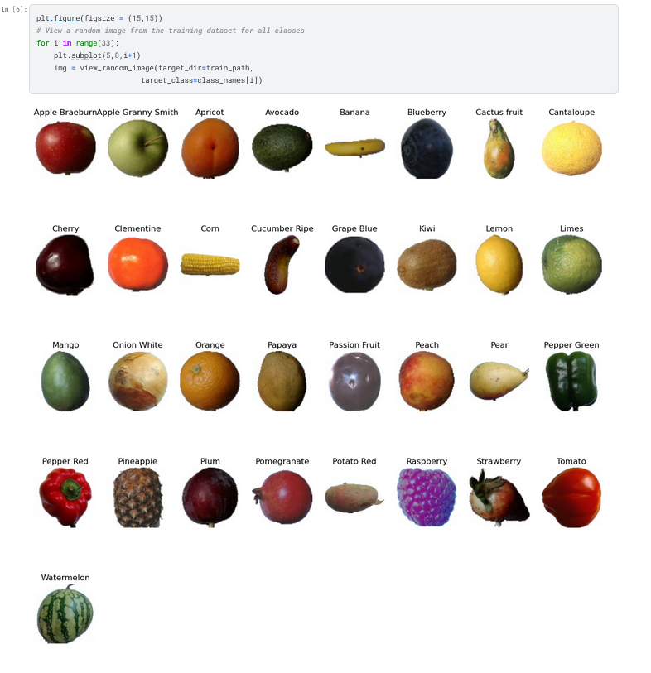

Modelling

This code snippet defines the architecture of a convolutional neural network (CNN),The network consists of several layers arranged sequentially to process input images and extract meaningful features for classification.

The Conv2D layers serve as the backbone of the model, applying filters to the input image to detect features like edges, textures, and patterns. The MaxPooling2D layers then downsample the feature maps, reducing their spatial dimensions while retaining important information.

Following these convolutional and pooling layers, the Flatten layer reshapes the output into a one-dimensional vector, preparing it for input into the fully connected Dense layers. These dense layers act as classifiers, analyzing the extracted features to make predictions about the input image's class.

The ReLU activation function is applied throughout the network, introducing non-linearity to enable the model to learn complex relationships within the data. Finally, the softmax activation function in the last dense layer converts the model's raw output into probability distributions across the different classes, facilitating classification.

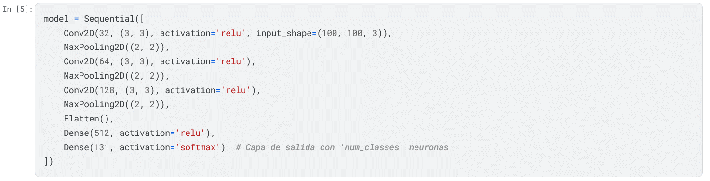In essence, this CNN architecture encapsulates a hierarchical approach to image understanding, leveraging layers of abstraction to transform raw pixel values into meaningful predictions about the content of the input images.

this code snippet compiles the CNN model with specified optimizer, loss function, and evaluation metric, and then proceeds to train the model using training data provided by the generator while validating its performance on separate validation data.

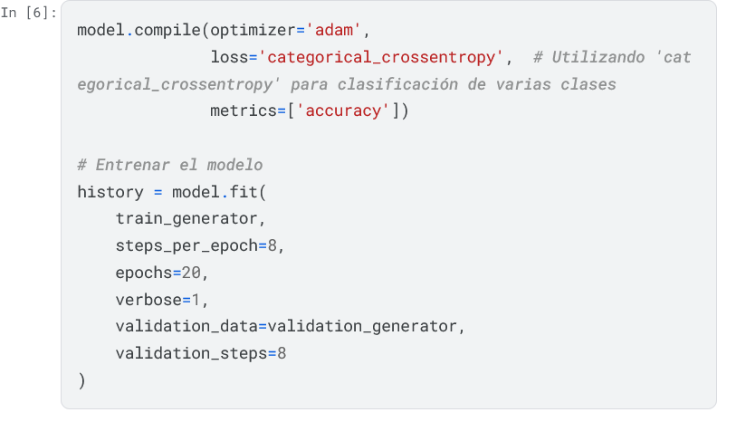

Refrences

<https://docs.python.org/3/>

<https://www.tensorflow.org/api_docs>

<https://pandas.pydata.org/docs/>

<https://numpy.org/doc/>

<https://stackoverflow.com/>

<https://chatgpt.com/?oai-dm=1>

The report should be based on the student’s own work and in case of using any parts or copying any figures or diagrams from previous work this should be properly referenced according to the format explained below.

A numbered list of references must be provided at the end of the paper. The list should be arranged in the order of citation in text, not in alphabetical order. List only one reference per reference number.

Each reference number should be enclosed by square brack­ets. In text, citations of references may be given simply as “in [1] . . .” rather than as “in reference [1] . . .” Similarly, it is not necessary to mention the authors of a reference unless the mention is relevant to the text. It is almost never useful to give dates of references in text. These will usually be deleted by Staff Editors if included.

Footnotes or other words and phrases that are not part of the reference format do not belong on the reference list. Phrases such as “For example,” should not introduce references in the list, but should instead be given in parentheses in text, followed by the reference number, i.e., “For example, see [5].”

## References Format

Sample correct formats for various types of references are as follows.

*Books:*

1. G. O. Young, “Synthetic structure of industrial plastics,” in *Plastics*, 2nd ed., vol. 3, J. Peters, Ed. New York: McGraw-Hill, 1964, pp. 15–64.
2. W.-K. Chen, *Linear Networks and Systems*. Belmont, CA: Wadsworth, 1993, pp. 123–135.

*Periodicals:*

1. J. U. Duncombe, “Infrared navigation—Part I: An assess­ment of feasibility,” *IEEE Trans. Electron Devices*, vol. ED-11, pp. 34–39, Jan. 1959.
2. E. P. Wigner, “Theory of travelling-wave optical laser,” *Phys. Rev.*, vol. 134, pp. A635–A646, Dec. 1965.
3. E. H. Miller, “A note on reflector arrays,” *IEEE Trans. Antennas Propagat.*, tobe *Articles from Conference Proceedings (published):*
4. D. B. Payne and J. R. Stern, “Wavelength-switched pas­sively coupled single-mode optical network,” in *Proc. IOOC-ECOC*, 1985, pp. 585–590.

*Papers Presented at Conferences (unpublished):*

1. D. Ebehard and E. Voges, “Digital single sideband detec­tion for interferometric sensors,” presented at the 2nd Int. Conf. Optical Fibre Sensors, Stuttgart, Germany, 1984.

*Standards/Patents:*

1. G. Brandli and M. Dick, “Alternating current fed power supply,” U.S. Patent 4 084 217, Nov. 4, 1978.

*Technical Reports:*

1. E. E. Reber, R. L. Mitchell, and C. J. Carter, “Oxygen absorption in the Earth’s atmosphere,” Aerospace Corp., Los Angeles, CA, Tech. Rep. TR-0200 (4230-46)-3, Nov. 1968.

## References to Electronic Sources

The guidelines for citing electronic information as offered below are a modified illustration of the adaptation by the International Standards Organization (ISO) documentation sys­tem and the American Psychological Association (APA) style. Three pieces of information are required to complete each reference: 1) protocol or service; 2) location where the item is to be found; and 3) item to be retrieved. It is not necessary to repeat the protocol (i.e., http) in Web addresses after “Available” since that is stated in the URL.

1. J. Jones. (1991, May 10). *Networks*. (2nd ed.) [Online]. Available: <http://www.atm.com>

*Journals:*

1. R. J. Vidmar. (1992, Aug.). On the use of atmospheric plasmas as electromagnetic reﬂectors. *IEEE Trans. Plasma Sci.* [Online]. *21(3)*, pp. 876–880. Available: <http://www.halcyon.com/pub/journals/21ps03-vidmar>

*Papers Presented at Conferences:*

1. PROCESS Corp., MA. Intranets: Internet technologies deployed behind the firewall for corporate productivity. Presented at INET96 Annu. Meeting. [Online]. Available: <http://home.process.com/Intranets/wp2.htp>

*Reports and Handbooks:*

1. S. L. Talleen. (1996, Apr.). The Intranet Ar­chitecture: Managing information in the new paradigm. Amdahl Corp., CA. [Online]. Available: <http://www.amdahl.com/doc/products/bsg/intra/infra/html>

*Computer Programs and Electronic Documents:*

1. A. Harriman. (1993, June). Compendium of genealog­ical software. *Humanist*. [Online]. Available e-mail: HUMANIST@NYVM Message: get GENEALOGY REPORT